In This Together
How to Protect Yourself & Others from COVID-19

As the situation surrounding COVID-19 (coronavirus) develops, we want to thank you for your efforts to take care of yourself and one another in order to reduce exposure. Here are some actions you can take to stay healthy and prevent the spread of illness:
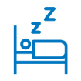

If you are feeling unwell, stay home and rest.

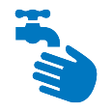
Wash your hands with soap for 20 seconds periodically throughout the day.

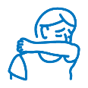
Cover coughs and sneezes with your elbow or a tissue.

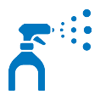
Clean high-touch surfaces.

Stand away from people, when possible.

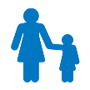
With kids, keep calm—and stay on top of immunizations.

If you think you may have been exposed or are showing symptoms, please call your doctor or telehealth provider to discuss next steps. We also understand that this can be an anxious and stressful time. For help managing stress, turn to our employee assistance program (EAP) at [ENTER CONTACT INFORMATION HERE].

QUESTIONS?

Call the number on the back of your medical ID card or contact the [BENEFIT OR HR CENTER] at [ADD PHONE NUMBER AND/OR WEBSITE HERE].

